**IREVOLUTION: A DATA-DRIVEN EXPLORATION OF APPLE'S IPHONE IMPACT IN INDIA**

**Project Work Submitted by**

**Roll No: C21UG105STA002 Name: Balamurugan K**

**C21UG105STA007 Harish R**

**C21UG105STA013 Nadhin M**

**C21UG105STA022 Santhosh M**

**Under the Guidance of**

**Dr. M. GOVINDHAN, M.Sc., Ph.D.**

**Guest Lecturer**

**DEPARTMENT OF STATISTICS**

**GOVERNMENT ARTS COLLEGE**

**Dharmapuri – 636705**

**(Affiliated to Periyar University)**

**October – 2023**

**1. Introduction**

**1.1 Overview**

Our Project is about Revenue and Market Penetration of iPhone. We intend to investigate how the iPhone has penetrated the markets and how much revenue generated though data analytics and Tableau visualizations.

**1.2 Purpose**

Through the insightful Visualizations and the analysis, we gain a comprehensive understanding of the iPhone's revenue streams and its extensive market reach. From these visual representations enabling us to capture the complexities of market penetration providing actionable insights to optimize strategies and capitalize on iPhone's market success.

**1.3 Advantages & Disadvantages**

* + **Advantages**

1. By spanning data from 2006 to 2022, it enables a historical analysis, which is crucial for understanding the iPhone's evolution over time.
2. Expressing the increase in active users, sold units, and revenue in percentage terms provides a clear understanding of the growth rates.
3. The sheets provide a wide array of information, including RAM, ratings, prices, active users, units sold, and annual revenue.
4. The combination of tables and charts enhances data visualization, making it easier for readers to comprehend complex information.
   * **Disadvantages**
5. While the data is detailed, it lacks specific context for certain figures.
6. The representation lacks qualitative data such as customer reviews or feedback, which could provide a more nuanced understanding of customer preferences and satisfaction.
7. The data is historical, providing a retrospective view. Including future projections or market forecasts would make the information more actionable for businesses and analysts.
8. While the iPhone's data is detailed, a comparison with similar data from competitors would provide a broader perspective, allowing for a more comprehensive analysis of its market position.

**1.4 APPLICATIONS**

1. By studying the trends in active users, units sold, and revenue, analysts can identify patterns and make predictions about future market behaviour.
2. Businesses, especially those in the technology sector, can use this data to formulate strategic plans. Understanding the increase in active users and units sold helps in anticipating market demand.
3. Companies involved in smartphone manufacturing can analyse the RAM, ratings, and prices data to understand consumer preferences.
4. Investors and financial analysts can utilize this data to assess the financial health and growth potential of Apple Inc.
5. Marketers can use the data on active users and units sold to target specific demographics effectively.
6. By analysing the average ratings data, companies can gain insights into customer satisfaction levels.

**2. Problem Definition & Design Thinking**

**2.1 Empathy map**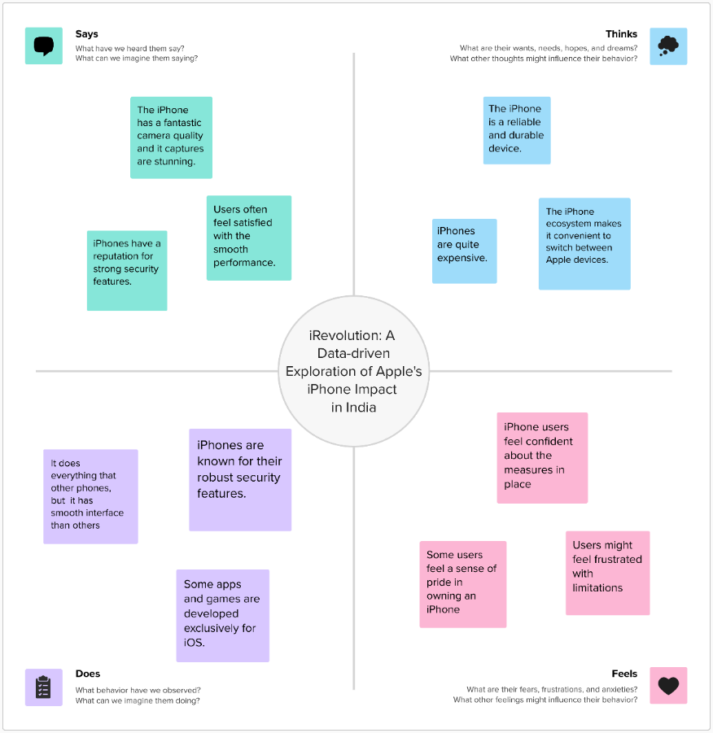

**Discussion:**

Using the Empathy Map, we can analyze the thinking way of customers or buyers for iPhone like how it feels and looks.

**2.2 Ideation & Brainstorming map**

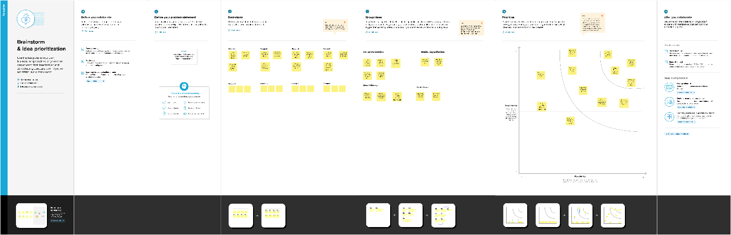

**Discussion:**

In this Brainstorm map, we can create and understand the question. Using Analysis, we get a solution for the questions.

**3. Statistical Analysis**

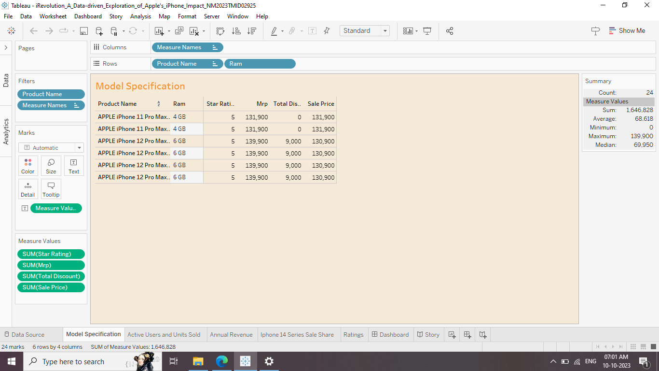

**Discussion:**

This sheet represents the RAM, Ratings, and Prices from the Pro Max series from the iPhone 11 and 12 series. In Apple iPhone 11 Pro Max maximum RAM is 4GB and it didn’t get any discount from MRP and In Apple iPhone 12 Pro Max maximum RAM is 6GB and it get up to ₹9000 discount from MRP

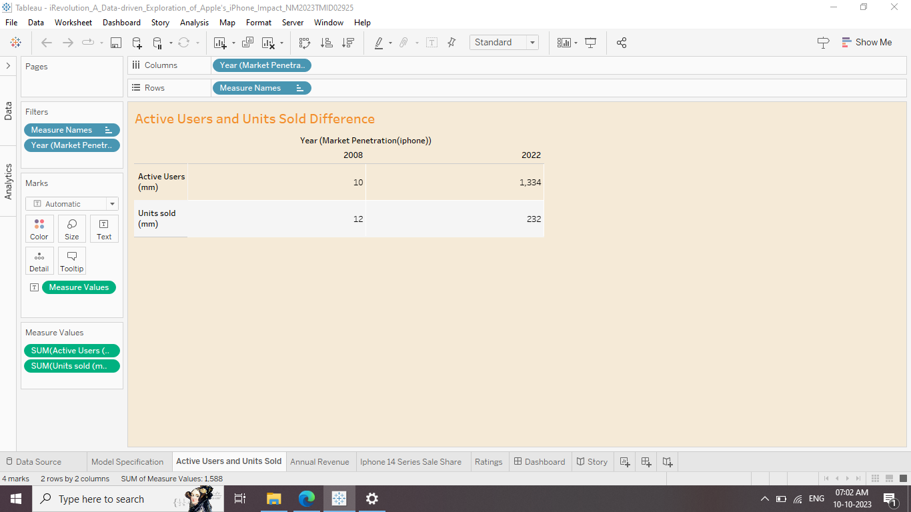

**Discussion:**

This table shows the Active Users and Units Sold from 2008 to 2022. They are Active users from 10 million to 1,334 million which is increased by approximately 13,240%, and They are Sold Units from 12 million to 232 million which is increased by approximately 1833.33%.

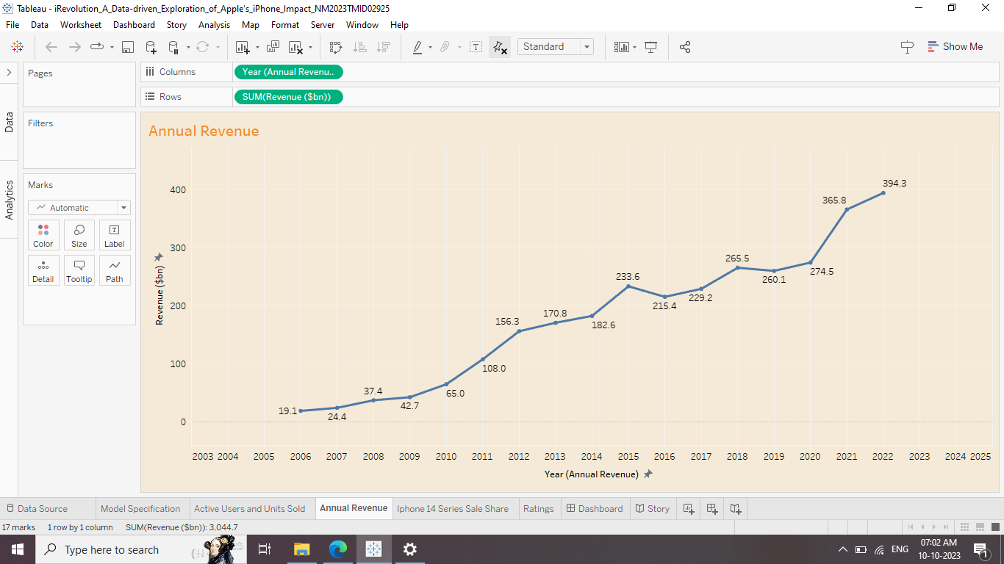

**Discussion:**

This chart represents about Annual Revenue of iPhone from 2006 to 2022. The Revenue generated by iPhone is from 19.1 billion to 394.3 which is approximately 1963.76%.

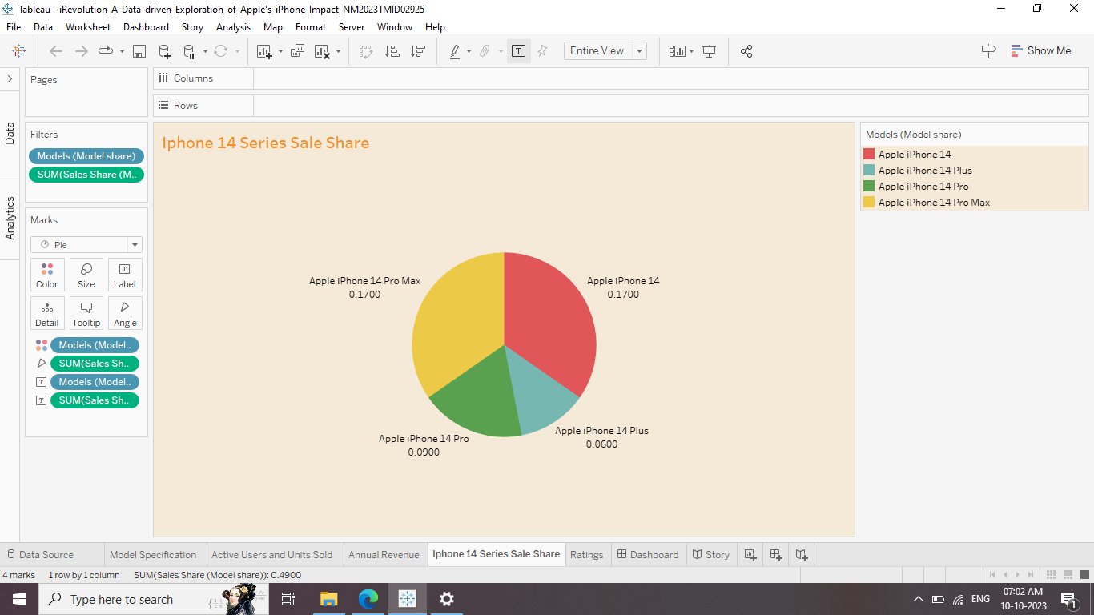

**Discussion:**

This pie chart represents the sales share of the iPhone 14 series in the market. In this sheet which Apple iPhone 14 and Apple iPhone 14 Pro Max holds an equal share about 0.17 and Apple iPhone 14 Pro holds 0.09 and Apple iPhone 14 plus holds 0.06 market share.

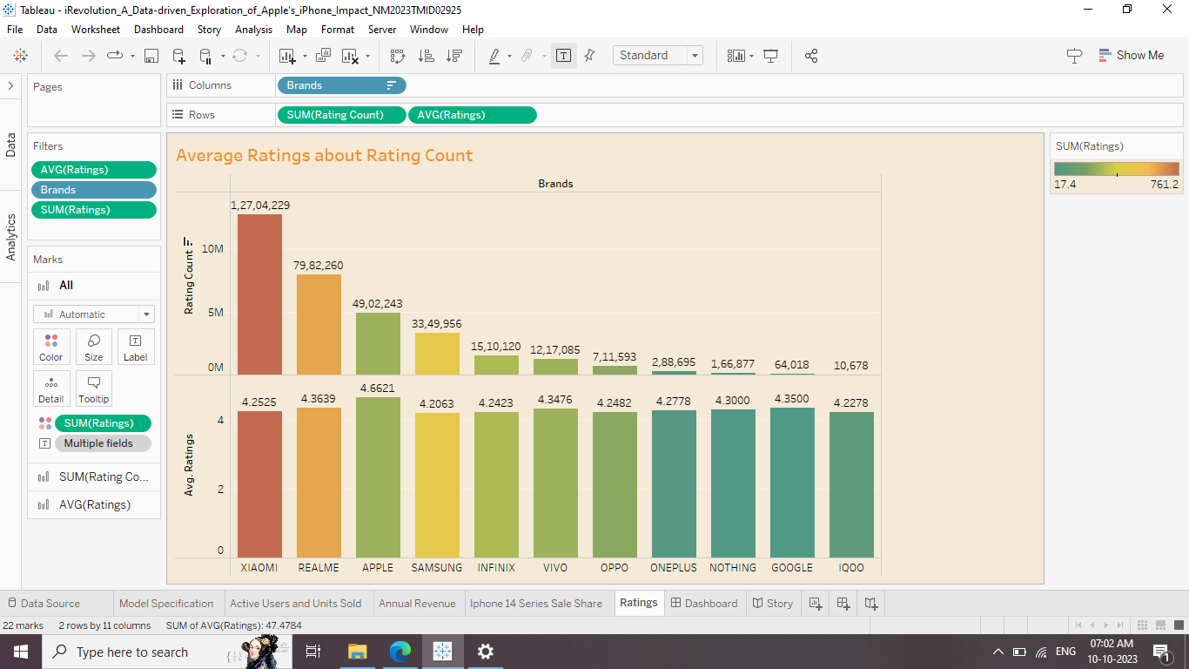

**Discussion:**

From this chart we know about the average ratings of mobile companies under the count of ratings, and also find that the iPhone is in 3rd place in the count of ratings and 1st place in the average ratings

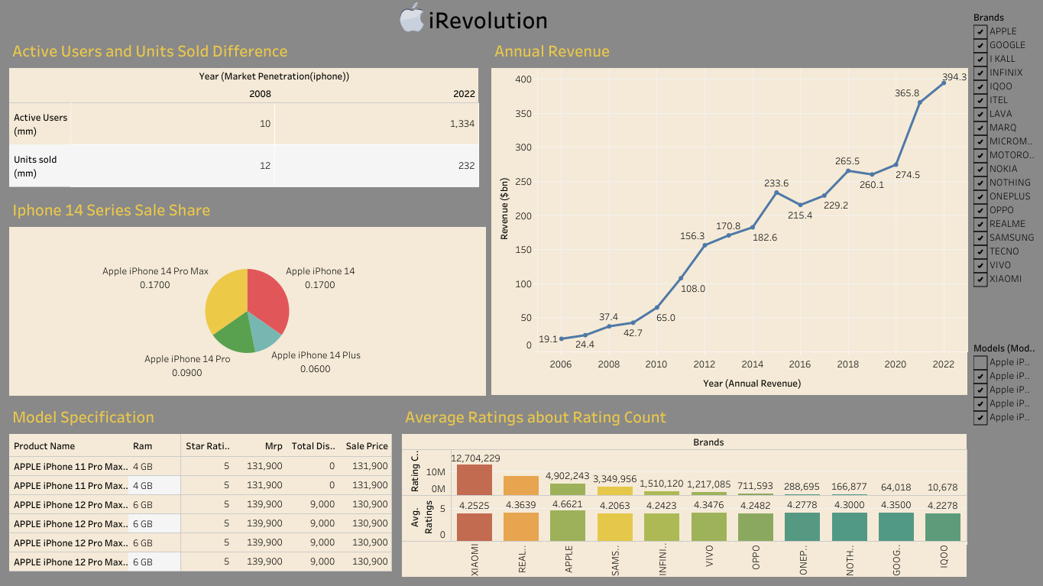

**Discussion:**

This dashboard shows the revenue and market penetration of the iPhone and the impact of the iPhone.

**4. CONCLUSION**

* This data sheet presents a comprehensive overview of the iPhone Pro Max series, focusing on the 11 and 12 models.
* Active users surged from 10 million to 1,334 million (a 13,240% increase), with units sold rising from 12 million to 232 million (an 1833.33% increase) by 2022.
* Annual revenue witnessed an exponential growth from 19.1 billion to 394.3 billion (a 1963.76% increase) from 2006 to 2022.
* Despite being ranked 3rd in the count of ratings, the Pro Max series claimed the top spot in average ratings, showcasing exceptional consumer satisfaction and market dominance.
* This data underscores Apple's unparalleled success, emphasizing both its massive market reach and remarkable customer loyalty

**5. FUTURE SCOPE**

The data presented in this sheets not only offers a historical perspective on the iPhone Pro Max series but also provides invaluable insights for future analysis. Researchers and market analysts can utilize this data to forecast market trends and consumer preferences, aiding in the development of future iPhone models and pricing strategies. Businesses can leverage this information to anticipate demand, optimize supply chains, and enhance customer satisfaction. Investors can use these trends to make informed decisions, while policymakers can gauge the tech industry's economic impact. Furthermore, this data could be instrumental in guiding innovations and ensuring Apple's continued market leadership.